Experiment No 9
Roll No:24141030 Lab: PL-II

Theory:
1. Introduction to File Handling
File handling refers to the process of working with files stored on disk. Python provides built-in functions and methods to create, read, write, update, and delete files. File handling is essential for persistent data storage.

2. Types of Files
File Type | Description | Extension
Text Files | Store data as readable characters | .txt, .csv, .json
Binary Files | Store data in binary format | .bin, .dat, .jpg, .mp3

3. File Operations
Operation | Description
Open | Open a file for reading/writing
Read | Read data from a file
Write | Write data to a file
Append | Add data to the end of a file
Close | Close the file (release resources)

5. File Object Methods
Method | Description
read(size) | Reads specified bytes/characters
readline() | Reads one line
readlines() | Reads all lines into a list
write(string) | Writes string to file
writelines(list) | Writes list of strings
seek(offset) | Moves file pointer to position
tell() | Returns current file position
close() | Closes the file

6. Using with Statement
The with statement automatically closes the file when the block ends, even if an exception occurs.
with open("file.txt", "r") as f:
content = f.read()

7. Introduction to Exception Handling
Exceptions are runtime errors that disrupt the normal flow of program execution. Exception handling allows programs to gracefully handle errors without crashing.

8. Common Built-in Exceptions
Exception | Description
ZeroDivisionError | Division by zero
FileNotFoundError | File does not exist
ValueError | Invalid value
TypeError | Wrong data type
IndexError | Index out of range
KeyError | Key not found in dictionary
NameError | Variable not defined
IOError | Input/Output error

Programs and Code
1. Program to create and write data into a file
def write_to_file():
filename = input("Enter filename: ")
data = input("Enter data to write: ")
try:
with open(filename, 'w') as file:
file.write(data)
print(f"Data successfully written to {filename}")
except Exception as e:
print(f"Error: {e}")
write_to_file()
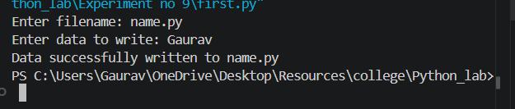
2. Program to read data from a file
def read_from_file():
filename = input("Enter filename to read: ")
try:
with open(filename, 'r') as file:
content = file.read()
print("\nFile content:")
print("-" * 30)
print(content)
print("-" * 30)
except FileNotFoundError:
print(f"Error: File '{filename}' not found")
except Exception as e:
print(f"Error: {e}")
read_from_file()
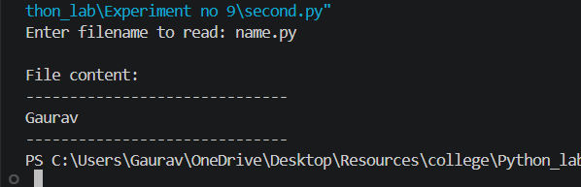
3. Program to append data into a file
def append_to_file():
filename = input("Enter filename: ")
data = input("Enter data to append: ")
try:
with open(filename, 'a') as file:
file.write(data + '\n')
print(f"Data successfully appended to {filename}")
with open(filename, 'r') as file:
print("\nUpdated file content:")
print(file.read())
except Exception as e:
print(f"Error: {e}")
append_to_file()
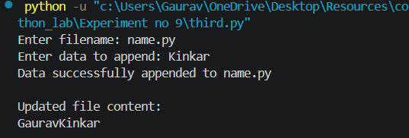
4. Program to count lines, words and characters in a file
def count_file_stats():
filename = input("Enter filename: ")
try:
with open(filename, 'r') as file:
content = file.read()
lines = content.count('\n') + (1 if content and not content.endswith('\n') else 0)
words = len(content.split())
characters = len(content)
print(f"\nStatistics for '{filename}':")
print(f"Lines: {lines}")
print(f"Words: {words}")
print(f"Characters: {characters}")
except FileNotFoundError:
print(f"Error: File '{filename}' not found")
except Exception as e:
print(f"Error: {e}")
count_file_stats()
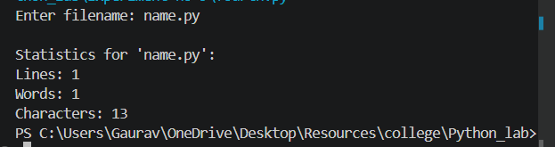
5. Program to copy contents from one file to another
def copy_file():
source = input("Enter source filename: ")
destination = input("Enter destination filename: ")
try:
with open(source, 'r') as src:
content = src.read()
with open(destination, 'w') as dest:
dest.write(content)
print(f"Successfully copied from '{source}' to '{destination}'")
print(f"Copied {len(content)} characters")
except FileNotFoundError:
print(f"Error: Source file '{source}' not found")
except Exception as e:
print(f"Error: {e}")
copy_file()
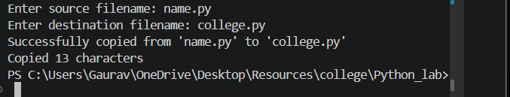
6. Program to ha ndle division by zero exception
def divide_numbers():
try:
a = float(input("Enter numerator: ")
b = float(input("Enter denominator: "))
result = a / b
print(f"{a} / {b} = {result}")
except ZeroDivisionError:
print("Error: Cannot divide by zero!")
except ValueError:
print("Error: Please enter valid numbers")
except Exception as e:
print(f"Unexpected error: {e}"
divide_numbers()
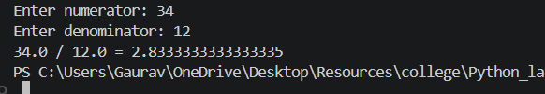
7. Program to handle invalid input exception
def get_integer():
while True:
try:
num = int(input("Enter an integer: "))
print(f"You entered: {num}")
return num
except ValueError:
print("Invalid input! Please enter a valid integer.")
print("=== Invalid Input Handler ===")
get_integer()
def process_numbers():
try:
numbers = input("Enter numbers separated by space: ").split()
numbers = [int(x) for x in numbers]
print(f"Sum: {sum(numbers)}")
print(f"Average: {sum(numbers)/len(numbers)}")
except ValueError:
print("Error: Please enter only numbers")
except Exception as e:
print(f"Error: {e}")

process_numbers()
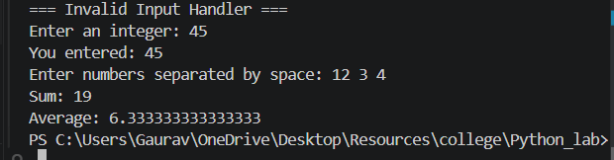
8. Program to use try–except–finally block
def file_operation():
filename = input("Enter filename: ")
file = None
try:
file = open(filename, 'r')
content = file.read()
print(f"File content:\n{content}")
except FileNotFoundError:
print(f"Error: File '{filename}' not found")
except PermissionError:
print(f"Error: Permission denied for '{filename}'")
except Exception as e:
print(f"Error: {e}")
finally:
if file:
file.close()
print("File closed successfully")
else:
print("File was not opened")
print("Program execution completed")
file_operation()
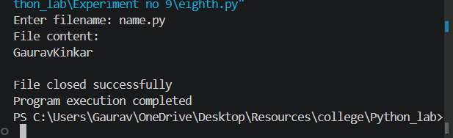
9. Program to create user-defined exception
class AgeError(Exception):
"""Custom exception for age validation"""
def __init__(self, message):
self.message = message
super().__init__(self.message)
class InsufficientBalanceError(Exception):
"""Custom exception for bank balance"""
pass
def validate_age():
try:
age = int(input("Enter age: "))
if age < 0:
raise AgeError("Age cannot be negative")
if age > 150:
raise AgeError("Age cannot exceed 150")
print(f"Valid age: {age}")
except AgeError as e:
print(f"Age Error: {e}")
except ValueError:
print("Error: Please enter a valid number")
def bank_withdraw():
try:
balance = 5000
amount = float(input("Enter withdrawal amount: "))
if amount > balance:
raise InsufficientBalanceError(f"Insufficient balance! Available: {balance}")
balance -= amount
print(f"Withdrawal successful! Remaining balance: {balance}")
except InsufficientBalanceError as e:
print(f"Transaction Error: {e}")
except ValueError:
print("Error: Please enter valid amount")
print("=== User-Defined Exceptions ===")
print("1. Age Validation")
validate_age()
print("\n2. Bank Withdrawal")
bank_withdraw()
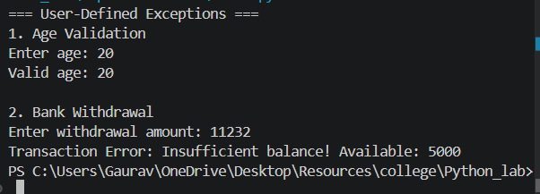
10. Program to demonstrate file exception handling
def file_exception_handling():
print("=== File Exception Handling Demo ===")
filename = "nonexistent.txt"
try:
with open(filename, 'r') as file:
print(file.read())
except FileNotFoundError:
print(f"Caught FileNotFoundError: The file '{filename}' does not exist")
filename = "readonly.txt"
try:
with open(filename, 'w') as file:
file.write("Initial content")
with open(filename, 'w') as file:
file.write("New content")
print(f"Successfully wrote to {filename}")
except PermissionError:
print(f"Permission denied for {filename}")
except Exception as e:
print(f"Unexpected error: {e}")
def safe_file_operation():
filename = input("\nEnter filename for operation: ")
operation = input("Choose operation (read/write/append): ").lower()
try:
if operation == 'read':
with open(filename, 'r') as f:
print("File content:")
print(f.read())
elif operation == 'write':
data = input("Enter data to write: ")
with open(filename, 'w') as f:
f.write(data)
print("Write successful")
elif operation == 'append':
data = input("Enter data to append: ")
with open(filename, 'a') as f:
f.write(data + '\n')
print("Append successful")
else:
print("Invalid operation")
except FileNotFoundError:
print(f"Error: File '{filename}' not found")
except PermissionError:
print(f"Error: Permission denied for '{filename}'")
except IOError as e:
print(f"IO Error: {e}")
except Exception as e:
print(f"Unexpected error: {e}")
else:
print("Operation completed successfully")
finally:
print("File operation attempt finished")
safe_file_operation()
file_exception_handling()
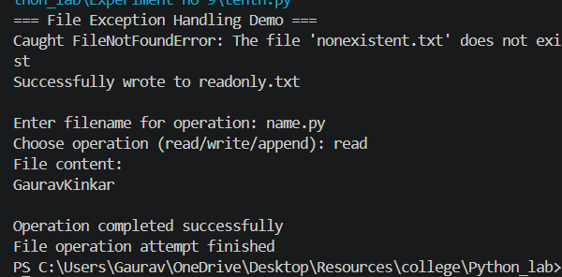
Conclusion:
In this experiment, we studied file handling operations (create, read, write, append, copy, count statistics) and exception handling techniques (try-except, try-except-else-finally, multiple exceptions, raising exceptions, user-defined exceptions). These concepts are essential for building robust programs that handle errors gracefully and persist data.

